## Easy Questions:

## Question 1. Create a pipeline name 'Without_Foreach_Example' to copy the Customer & Customer address table data into ADLS without using foreach activity.

Solution:-For this we’ll create two copy activity one will copy customer data and other will copy customerAddress data.

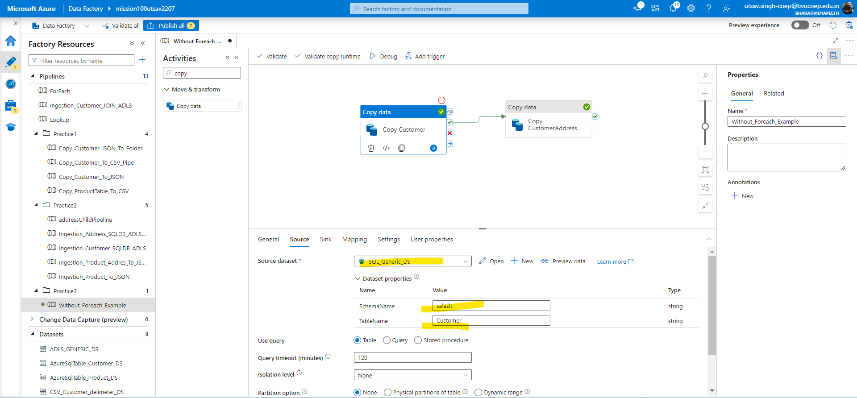

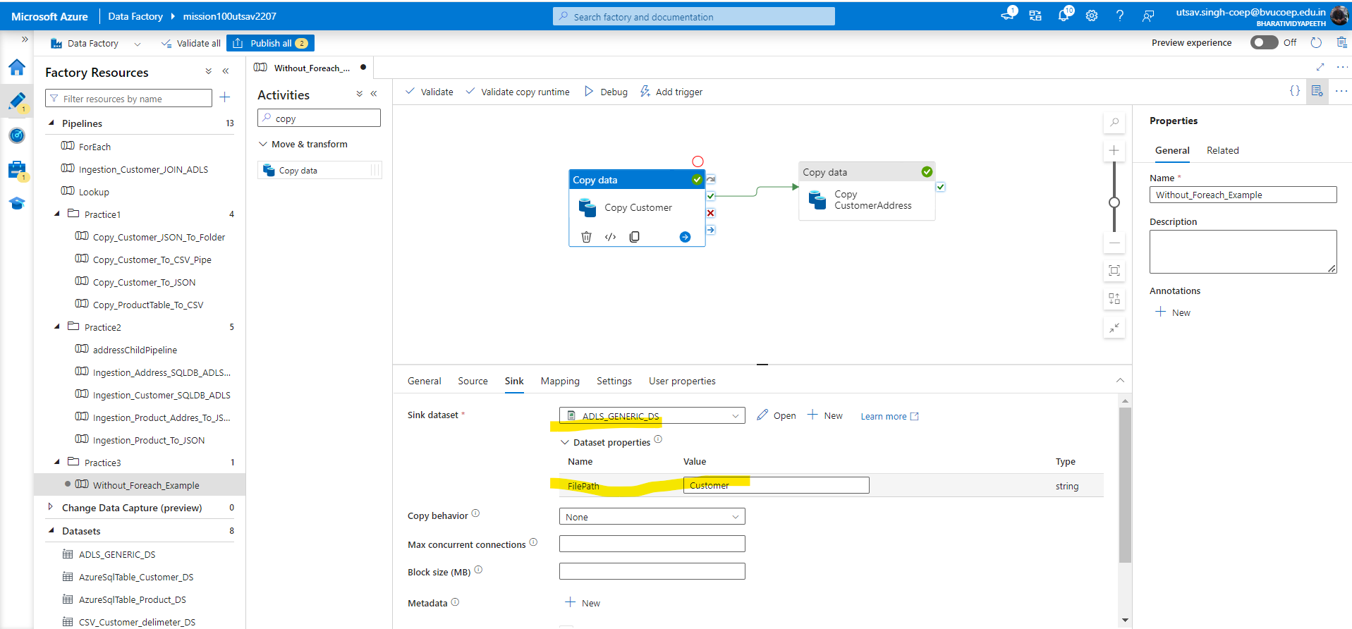

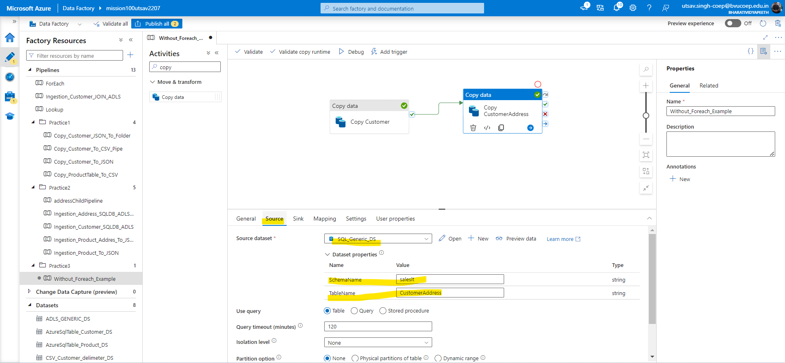

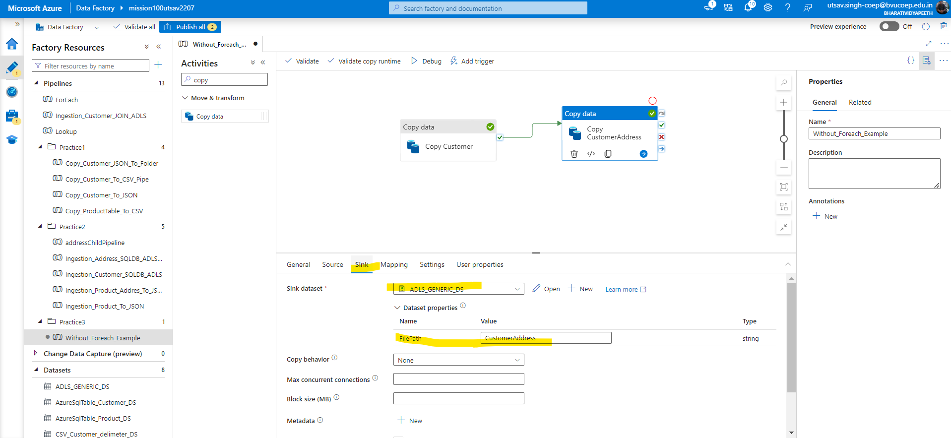

## Question 2. Create a pipeline name 'Foreach_Example' to copy the Customer & Customer address table data into ADLS using the one copy activity.

Solution:- Create a FOR each activity and within for each create one copy activity.

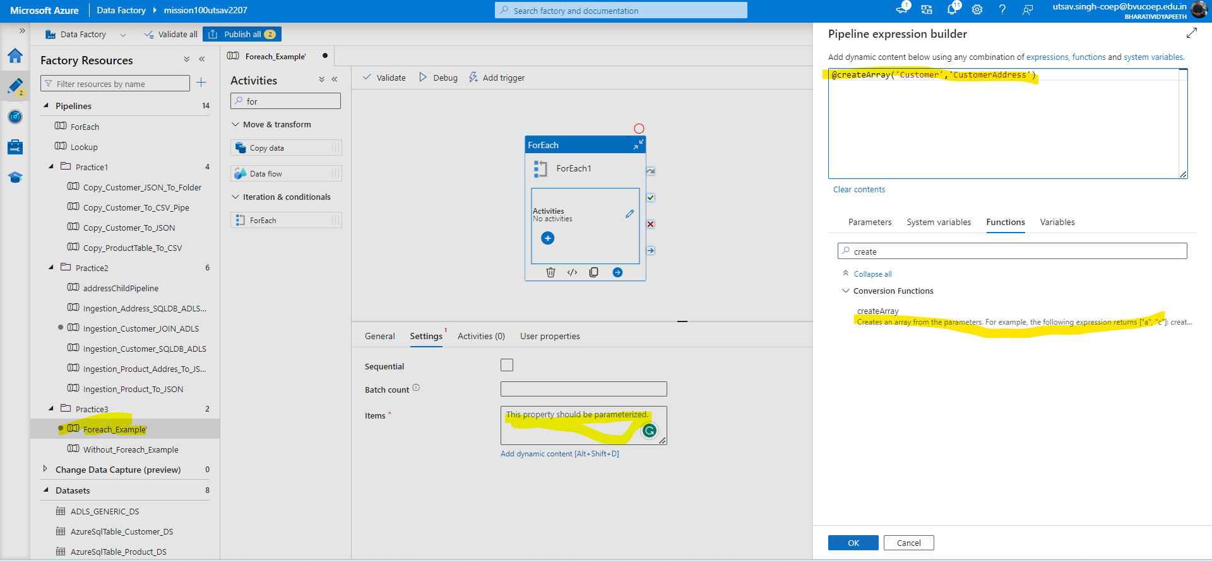

-Under table name call the foreach create array function.

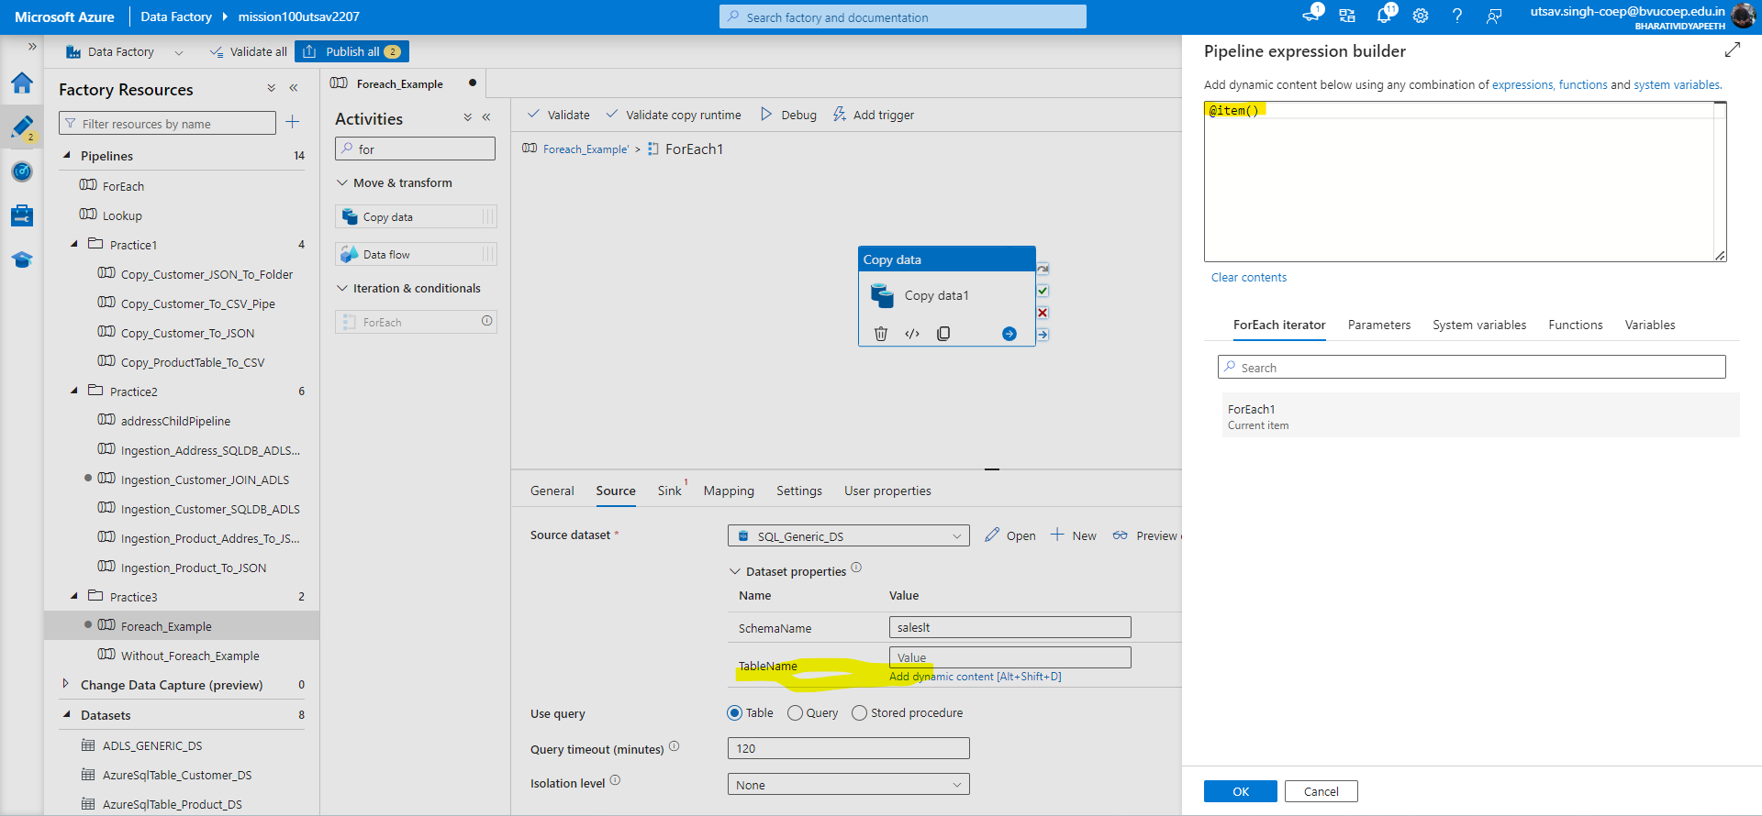

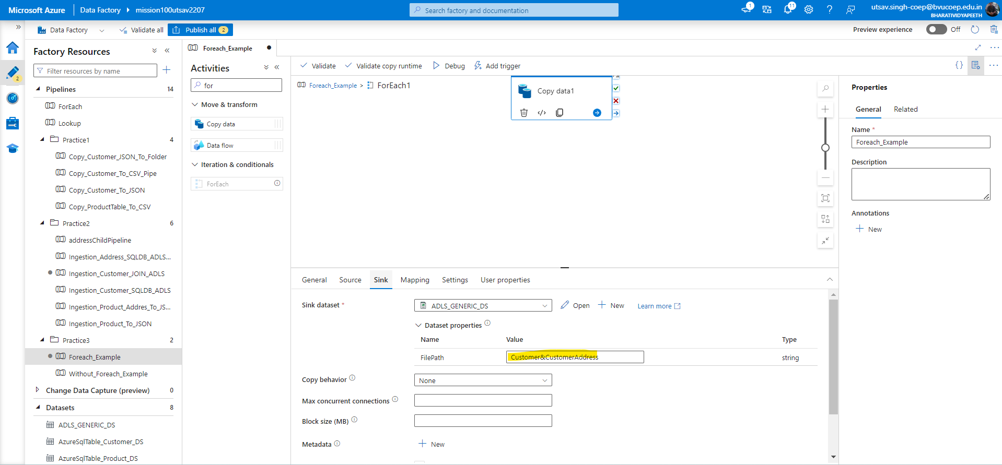

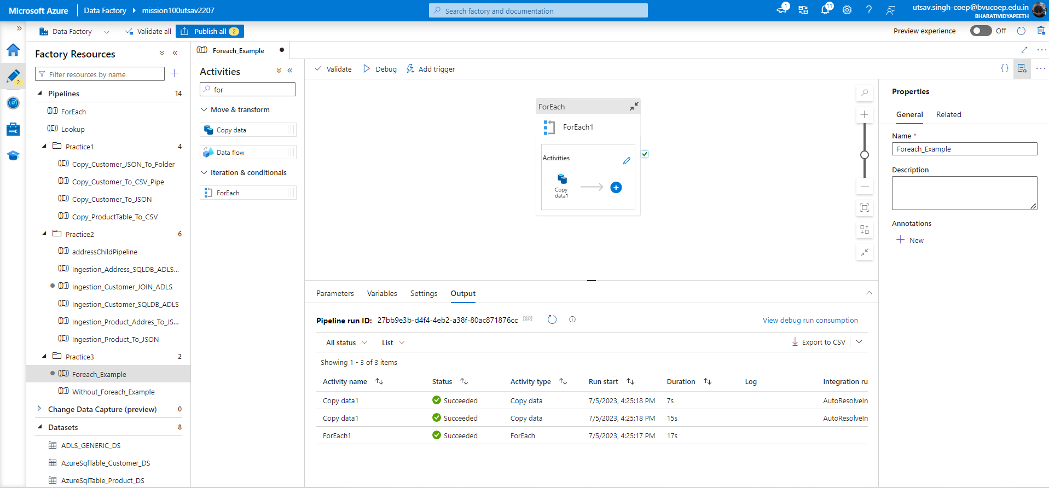

-And under the Customer&CustomerAddress it will pull both tables.

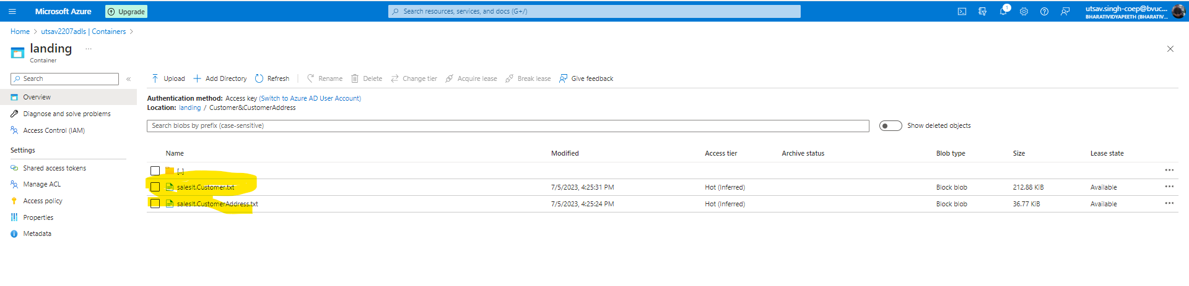

## Tricky Questions:

## Question 3. Create a pipeline name 'Foreach_Example_2' which solves the following business use case.Customer data is very important for our business. Hence whenever we have more than 100 records in the customer table,

## we copy the customer data to another table customer_copy within the sql db.

## 

## However whenever we do this copy, we first truncate the table 'customer_copy' and then copy the data from 'customer' table

## Hint : Use ADF to solve this problem.

Solution:-Firstly create lookup activity and then run the query in query tab and then create if activity with greater function to check more than 100 record in customer table. Then goto true condition within if activity and create copy activity there give generic dataset as source and in destination also give the same and click on Auto create table and run it then again in sink pre-copy script give -truncate table customer_copy.

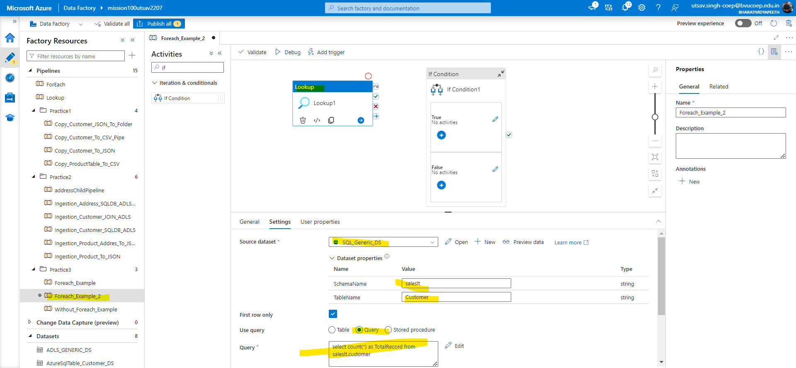

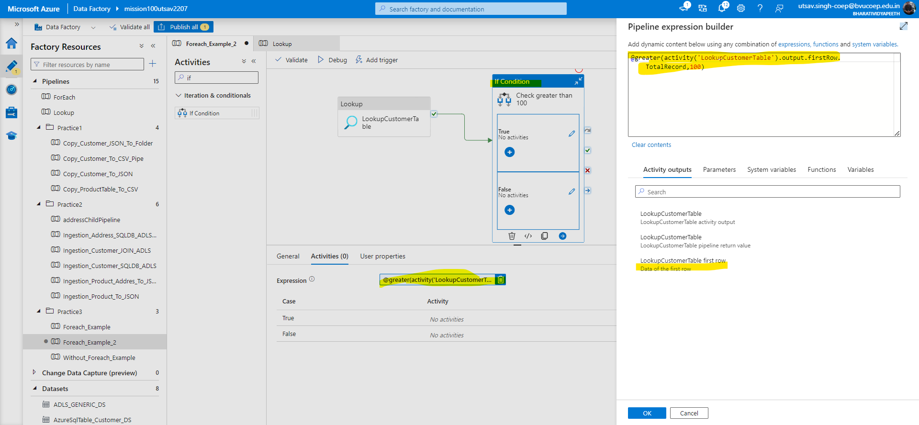

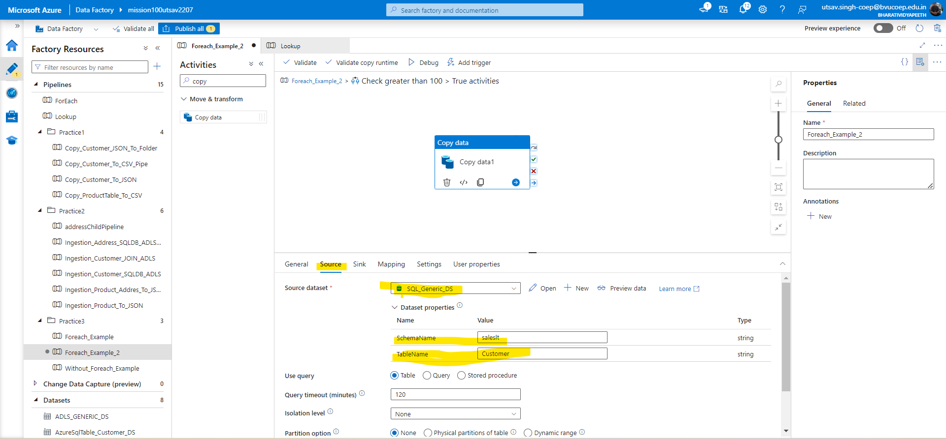

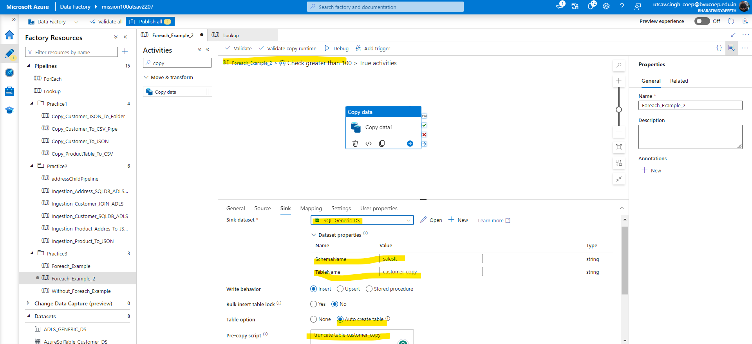

## Question 4. Business wants to move the data from 3 different tables (Customer, Product, CustomerAddress) to ADLS location in CSV format.

## However they want the make a pipeline in such a manner that All these copy happens through an individual pipeline, which is called by one common pipeline.

Solution:-We’ll first create three different copy activity pipeline for customer, product, customeraddress and finally will create a individual pipeline where we’ll call all three different pipelines.

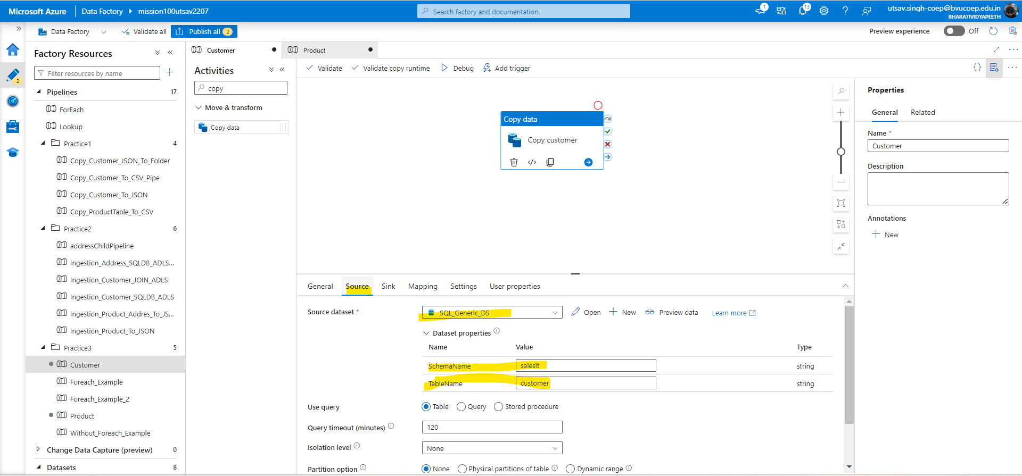

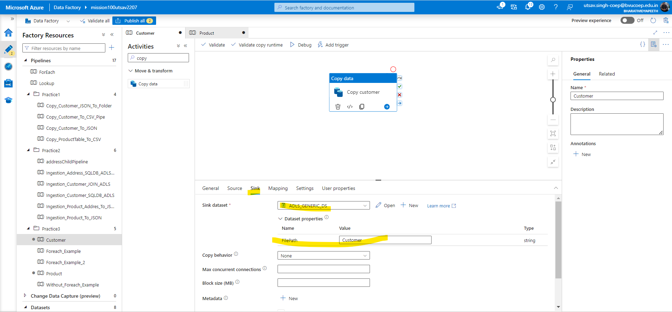

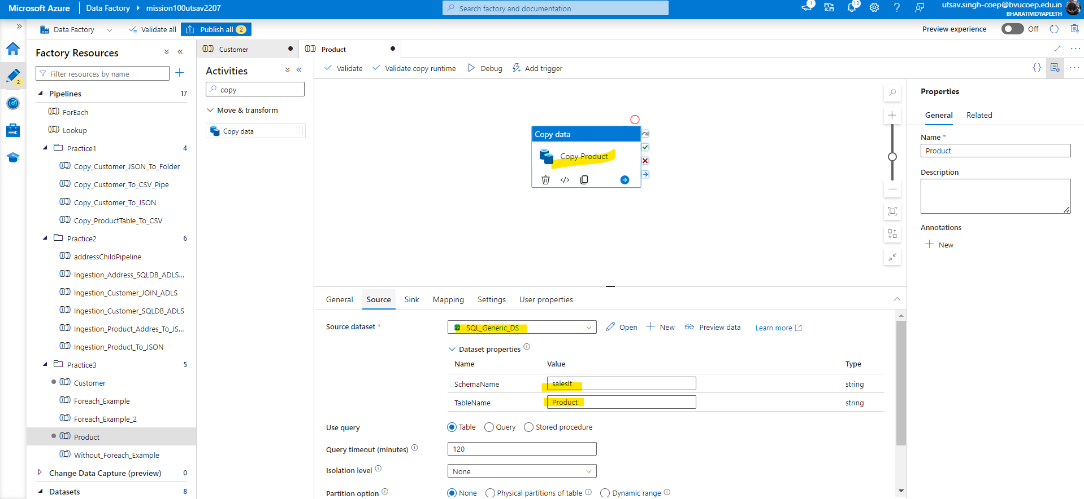

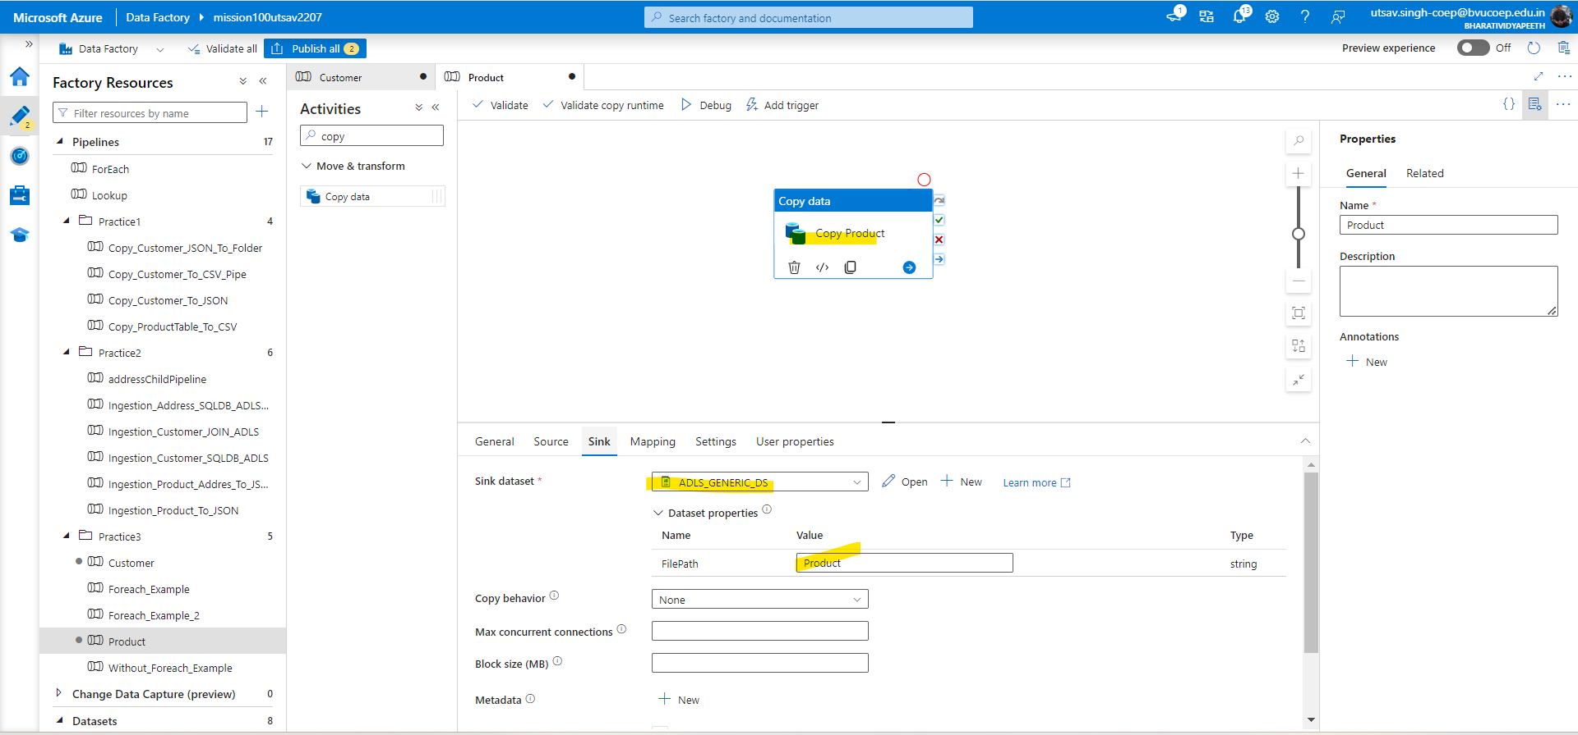

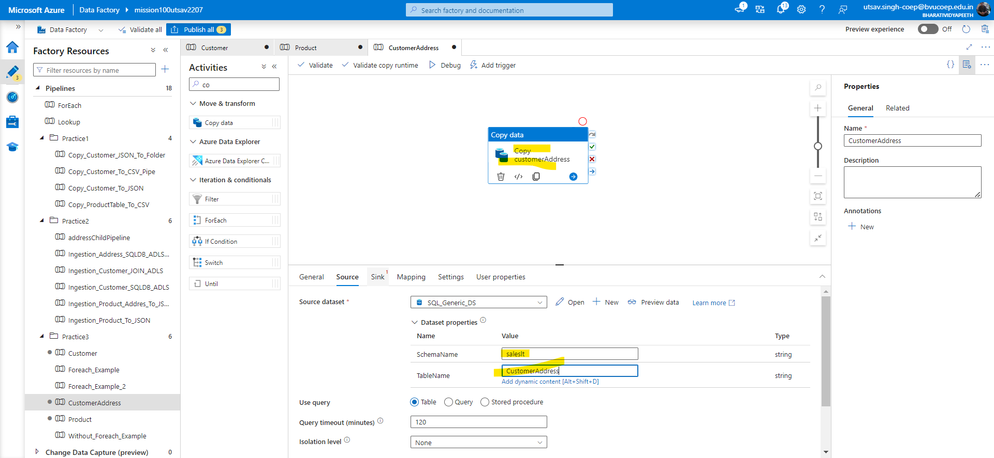

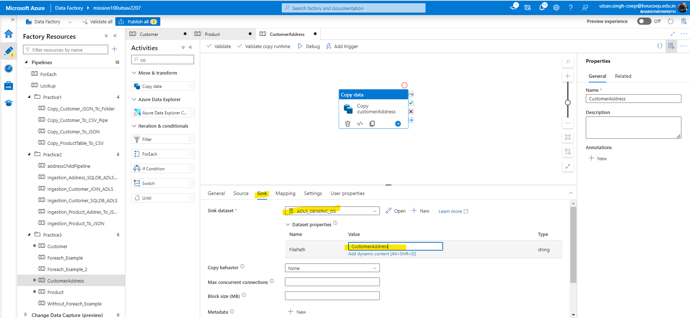

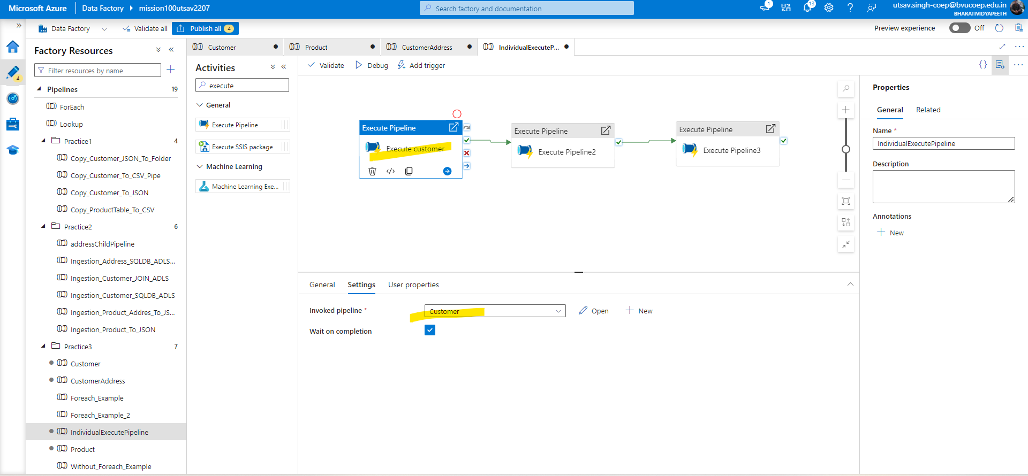

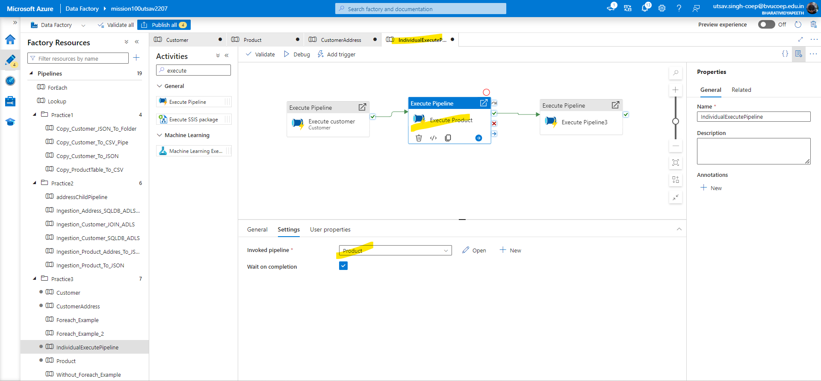

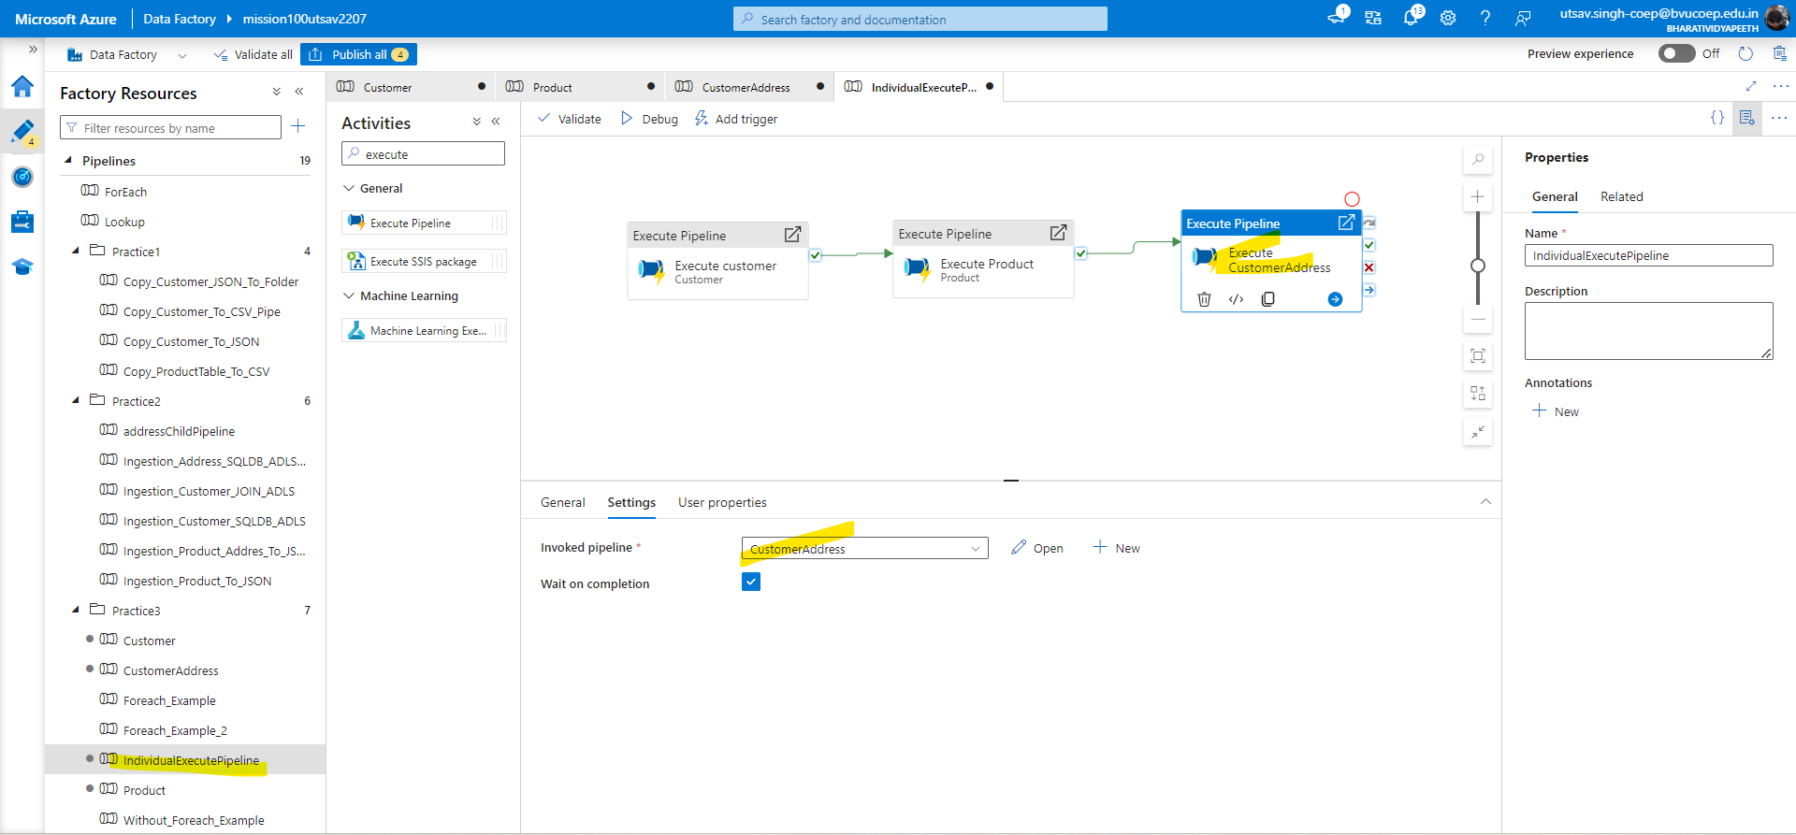

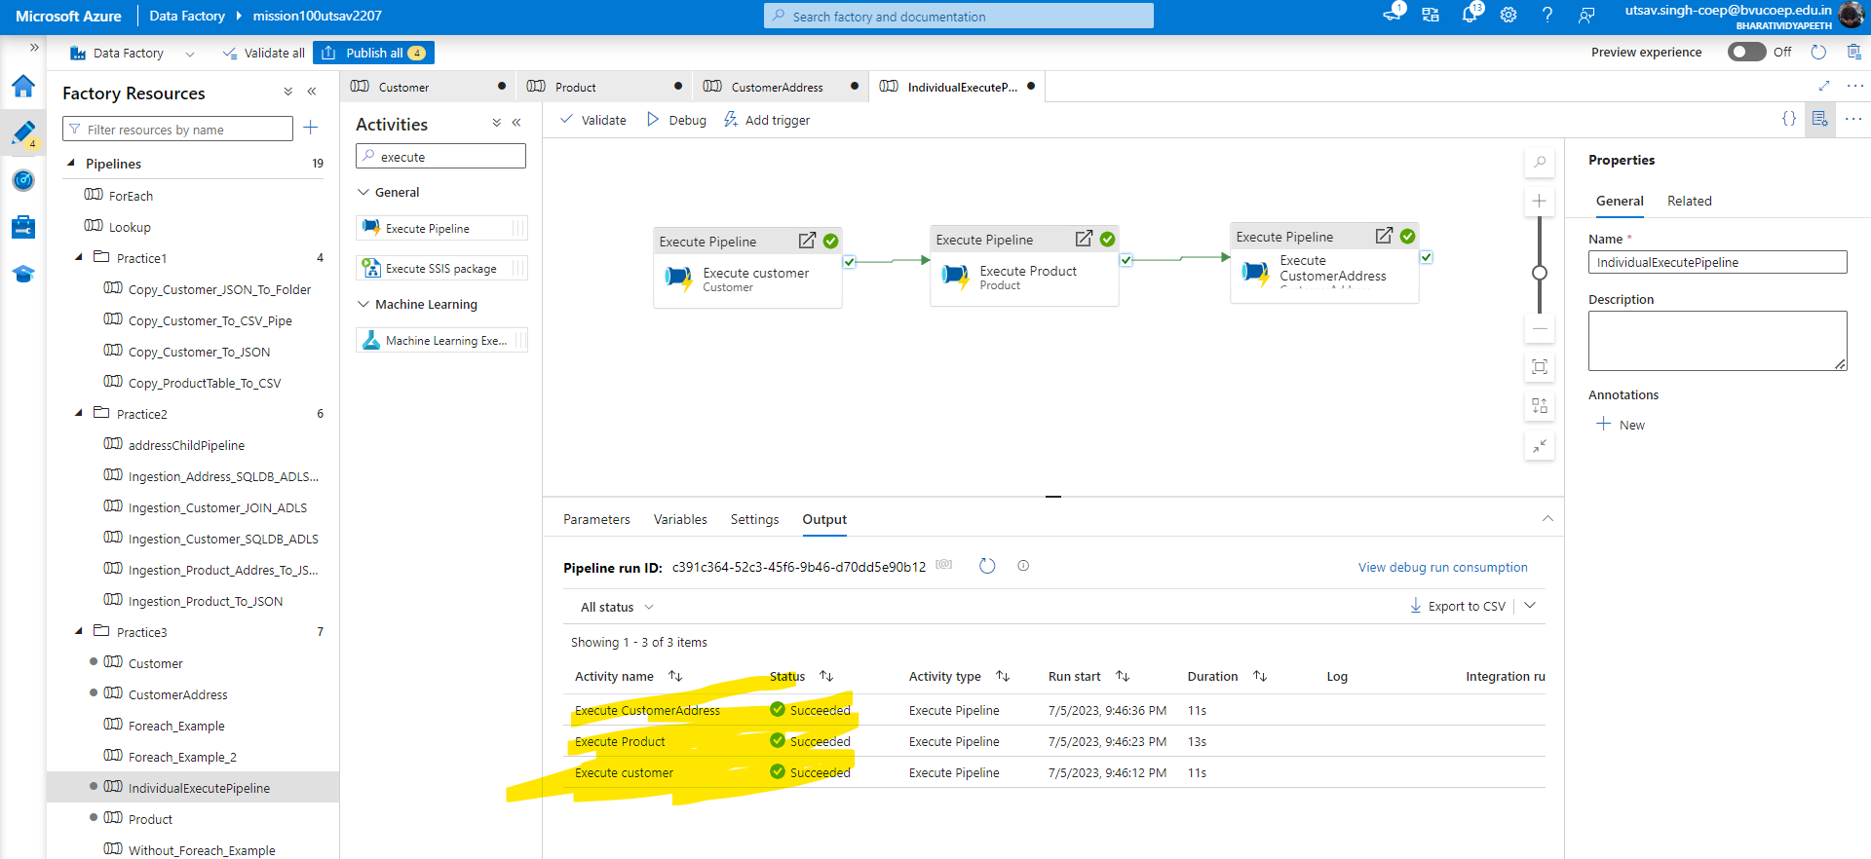

## Question 5. In the above case problem is that every time the pipeline runs it will overwrite the data. Ensure that all the data goes into

## Folder like (Customer/Year/Month/Day) to avoid any overwriting. Please rewrite the pipeline.

Solution:-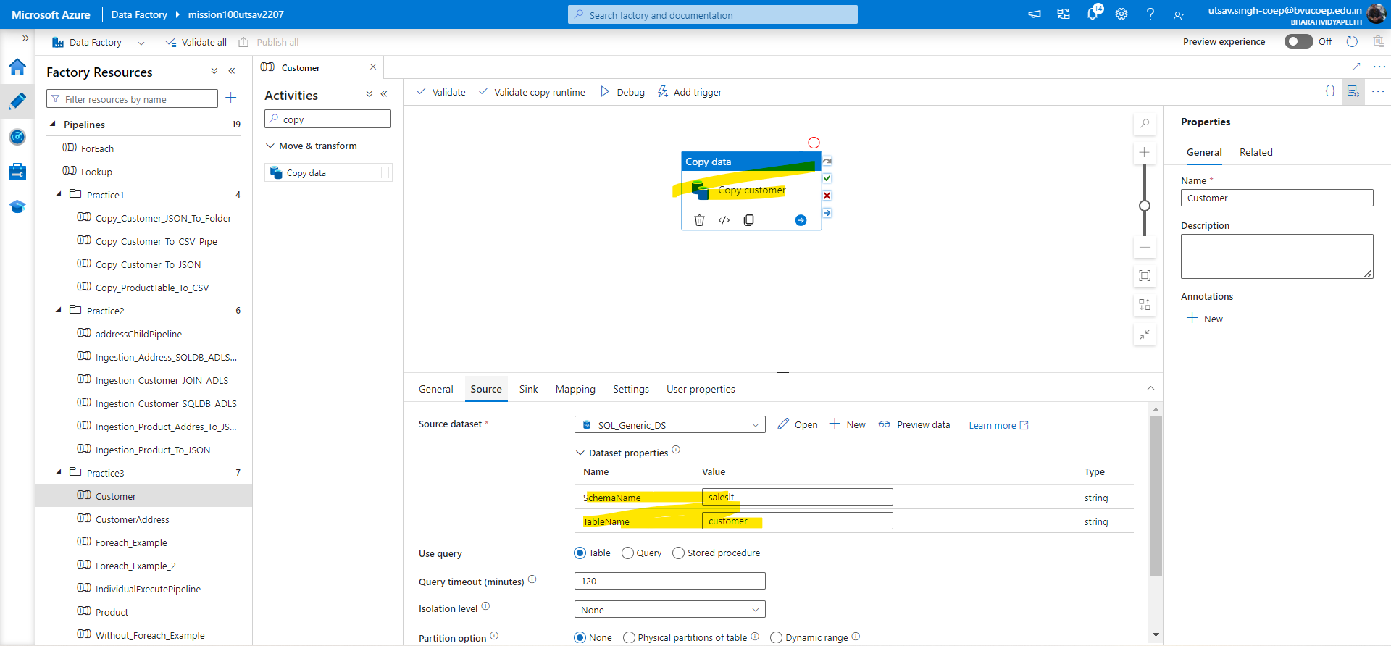

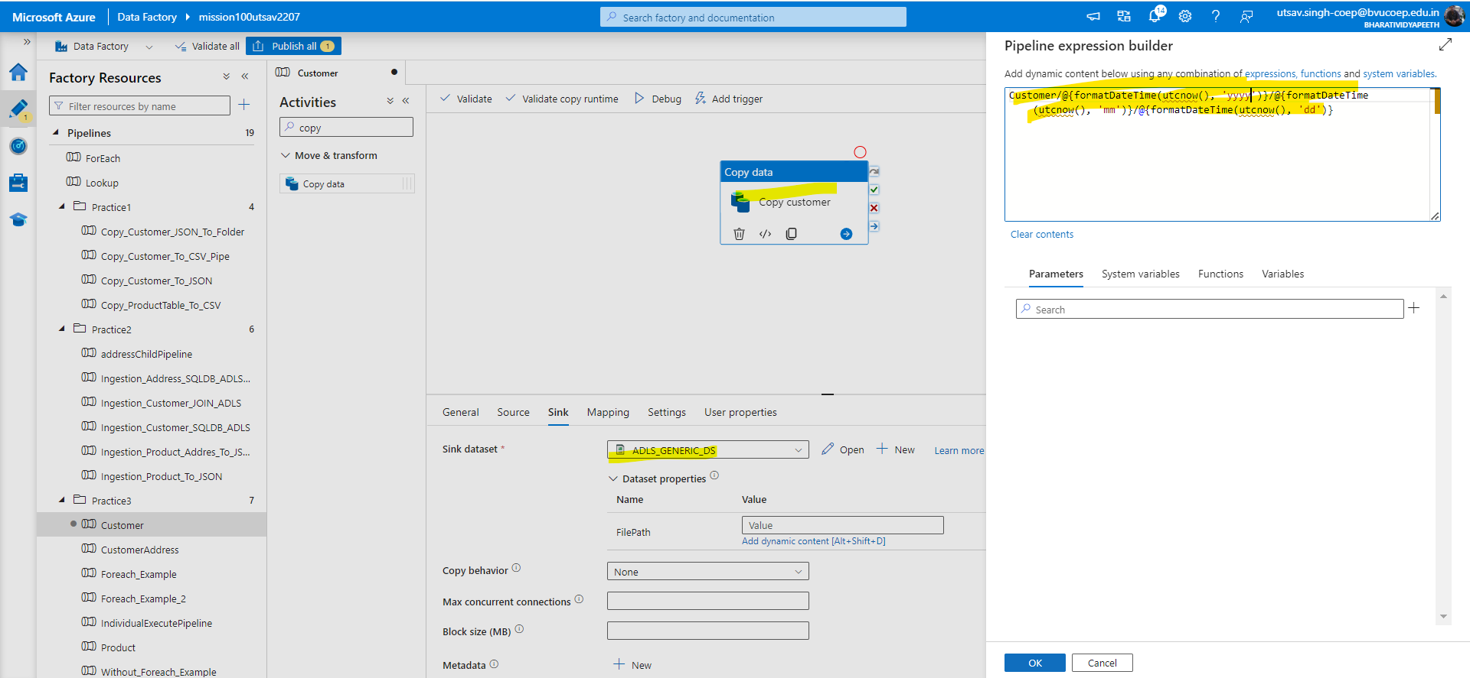

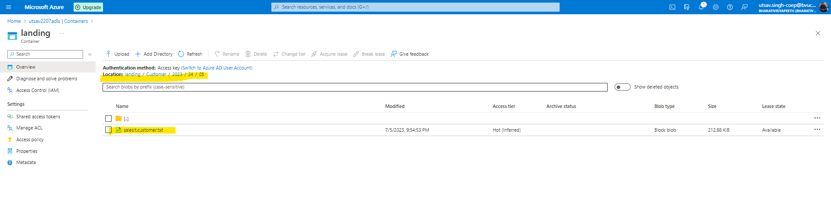

## Question 6. I am attaching a file, load this file into your ADLS location. This file contains a threshold value. Create a pipeline in such a manner that, it will first get the threshold value from this file and then check if the record count in the customer table is more than it or not. If yes then copy the customer data from SQL db to ADLS location in JSON format.

Solution:-Firstly upload threshold.csv(aliasing is imp. Like create csv file where type count variable name and the count then save it) file in ADLS then in ADF create two lookup activity for check threshold and Customer then use IF activity and give condition and within if condition create copy activity which copy’s customer data.

-Create lookup activity and new dataset which will read the threshold.csv file(file which you uploaded in ADLS)

